Annex to the OG-Core ↔ OSeMOSYS Coupling Map
Required Bridge Transformations for the Philippines-Generalized OG–CLEWS Workflow
Prepared 22 April 2026
Purpose. This addendum supplements the refined Philippines-generalization annex by making the bridge layer explicit in equations. It translates the demand-first integration logic in the Philippines CLEWs overview into a reusable, country-agnostic formula set for coupling OG-Core with a CLEWs/OSeMOSYS model. The intent is operational: a modeller should be able to implement the bridge objects, not only describe them conceptually.
Why this addendum is needed. The uploaded Philippines overview indicates that the first serious integration effort should focus on harmonized demands, and that the most policy-relevant feedbacks from CLEWs into OG are fuel imports, extraction, investments, emissions, land use, and water use. This document therefore writes down the minimum transformations required for a functioning iterative OG–CLEWS workflow.

1. Core implications from the Philippines use case
• The current Philippines CLEWs model is national, energy-system focused, and runs on annual demands that are further split into 30 timeslices. This means the bridge must include both an annual demand transformation and a timeslice-profile transformation.
• The integration priority is demand-first: OG informs CLEWs demand calculations through common macro-demographic assumptions, especially population and GDP growth.
• The first CLEWs-to-OG feedbacks should be annual fuel imports, domestic extraction, and investment requirements. These are the bridge objects that matter earliest for macro-fiscal analysis.
• Emissions, land footprint, and water use should be retained as bridge outputs even when they do not directly enter the OG equilibrium. They determine scenario admissibility, policy comparison, and welfare interpretation.

2. Bridge-layer schematic
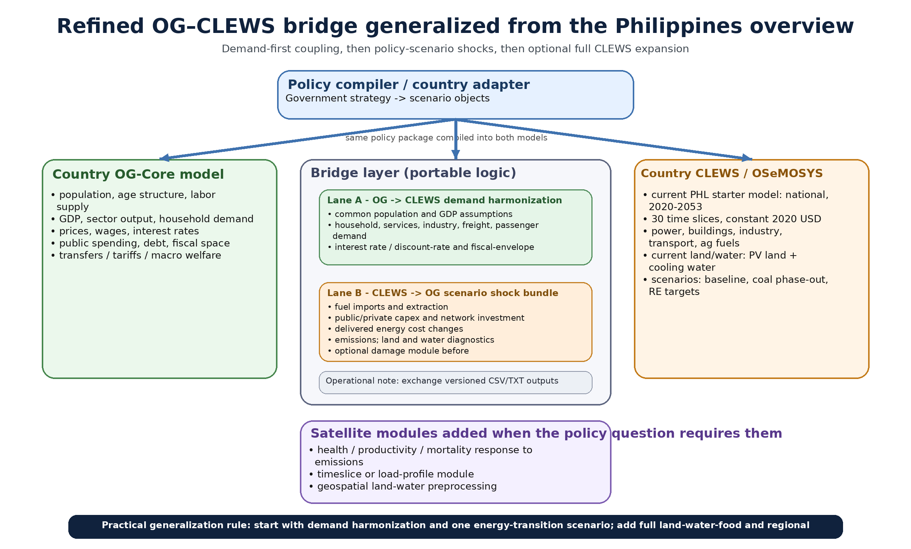
Figure 1. Refined OG–CLEWS bridge generalized from the Philippines overview, with the demand-first and scenario-feedback channels made explicit.

3. Required bridge transformations
Notation. The formulas below are intentionally generic. Index f denotes an end-use fuel or service in CLEWs;
Indices used below: i = OG consumption good; m = OG production sector; f = CLEWs fuel or end-use service; k = CLEWs technology or asset class; l = timeslice; t = year.

3.1 OG → CLEWs annual demand mapping
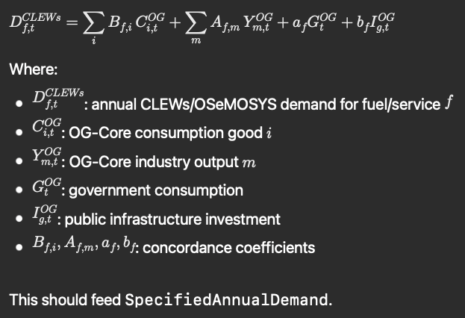
D_CLEWs[f,t] = Σ_i B[f,i]·C_OG[i,t] + Σ_m A[f,m]·Y_OG[m,t] + a[f]·G_OG[t] + b[f]·Ig_OG[t]
Use in bridge layer: Populates SpecifiedAnnualDemand for residential, services, transport, agriculture, water, and productive-energy end uses.
Interpretation: B maps OG consumption goods into CLEWs demands; A maps OG sectoral output into productive-service demands. The a and b terms capture public-service and infrastructure-related demand.

3.2 Annual demand to CLEWs timeslice demand
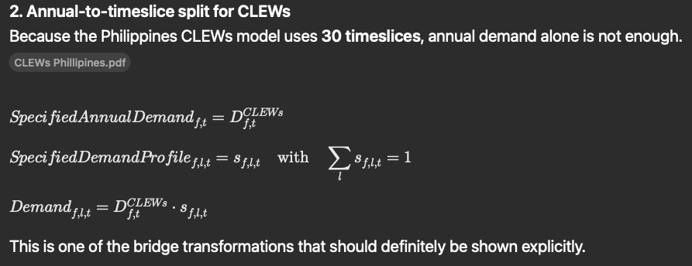
SpecifiedAnnualDemand[f,t] = D_CLEWs[f,t]; Demand[f,l,t] = D_CLEWs[f,t]·s[f,l,t]; Σ_l s[f,l,t] = 1
Use in bridge layer: Converts annual demand from OG into the timeslice structure required by OSeMOSYS/CLEWs.
Interpretation: Because the Philippines model uses 30 timeslices, annual demand must be paired with a demand-profile vector s[f,l,t]. OG-Core does not produce this profile natively; it must come from historical load shapes, engineering assumptions, or an auxiliary demand module.

3.3 Population–GDP harmonization rule
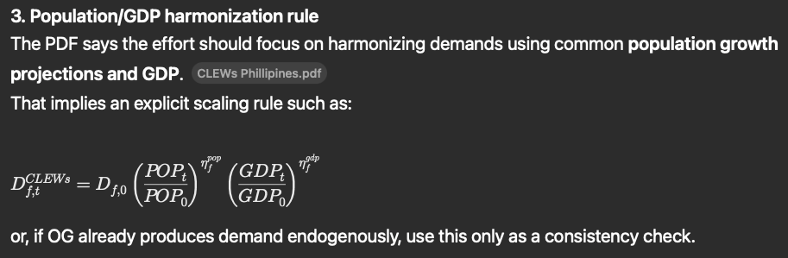
D_CLEWs[f,t] = D0[f]·(POP[t]/POP[0])^(η_pop[f])·(GDP[t]/GDP[0])^(η_gdp[f])
Use in bridge layer: Provides a consistency rule for demand projection when OG values are used to calibrate or validate the CLEWs demand baseline.
Interpretation: This is the lightest-weight harmonization device when the OG side does not yet produce fully endogenous demand by service. It can be used as a bridge prior, a calibration check, or a fallback projection method.

3.4 CLEWs → OG fuel-import and extraction mapping
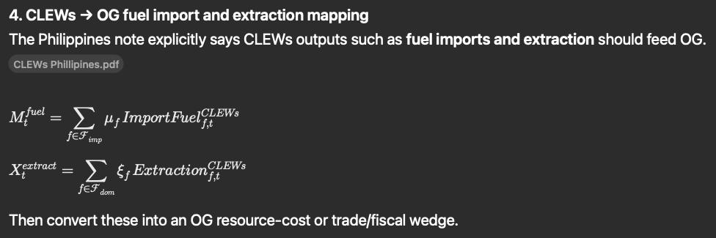
M_fuel[t] = Σ_f μ[f]·ImportFuel_CLEWs[f,t]; X_extract[t] = Σ_f ξ[f]·Extraction_CLEWs[f,t]
Use in bridge layer: Translates CLEWs energy-system results into macro-relevant external-dependence and domestic-resource objects for OG.
Interpretation: The μ and ξ coefficients convert physical imports and extraction into the value or wedge representation required by OG. Depending on calibration, these can enter as import-bill shocks, resource-income shocks, or production-cost wedges.

3.5 CLEWs → OG investment mapping
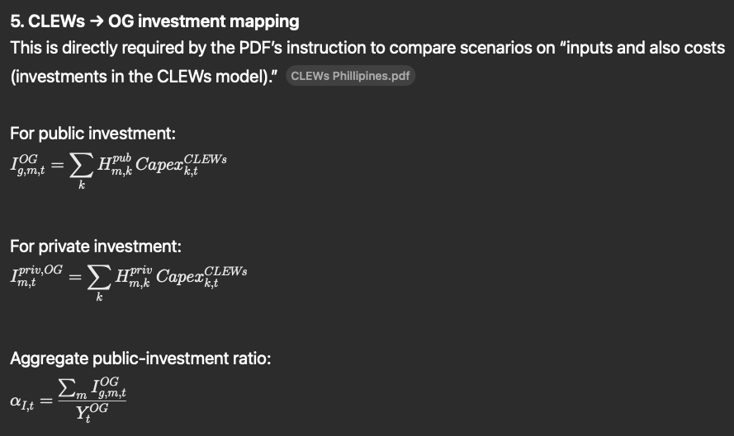
Ig_OG[m,t] = Σ_k H_pub[m,k]·Capex_CLEWs[k,t]; Ipriv_OG[m,t] = Σ_k H_priv[m,k]·Capex_CLEWs[k,t]; αI[t] = Σ_m Ig_OG[m,t] / Y_OG[t]
Use in bridge layer: Separates public and private CLEWs capital expenditure and routes each to the correct OG investment object.
Interpretation: H_pub and H_priv are concordance matrices from CLEWs technologies to OG sectors. This is the minimum transformation needed for a macro-fiscal reading of energy-transition or resilience scenarios.

3.6 CLEWs → OG delivered-cost wedge
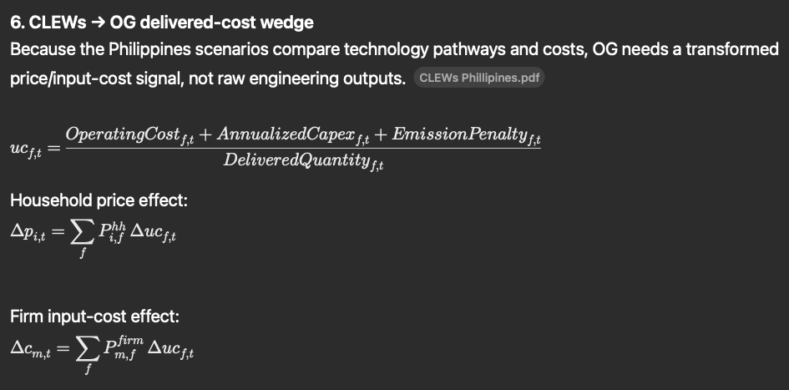
uc[f,t] = (OperatingCost[f,t] + AnnualizedCapex[f,t] + EmissionPenalty[f,t]) / DeliveredQuantity[f,t]
Use in bridge layer: Creates an annual unit-cost schedule that can shift household prices and firm input costs in OG.
Interpretation: Raw OSeMOSYS costs should not overwrite OG equilibrium prices. Instead, they should be converted into delivered-cost wedges by end use or fuel. AnnualizedCapex may be based on a financial recovery factor or another agreed annualization convention.

3.7 Transmission of delivered-cost wedges inside OG
Δp_household[i,t] = Σ_f P_hh[i,f]·Δuc[f,t]; Δc_firm[m,t] = Σ_f P_firm[m,f]·Δuc[f,t]
Use in bridge layer: Maps CLEWs unit-cost changes into consumption-price and production-cost channels in OG.
Interpretation: P_hh and P_firm are pass-through matrices. Depending on the OG implementation, these wedges can enter as consumption-tax equivalents, intermediate-cost shocks, or productivity-adjusted price wedges.

3.8 CLEWs reporting bridges for emissions, land, and water
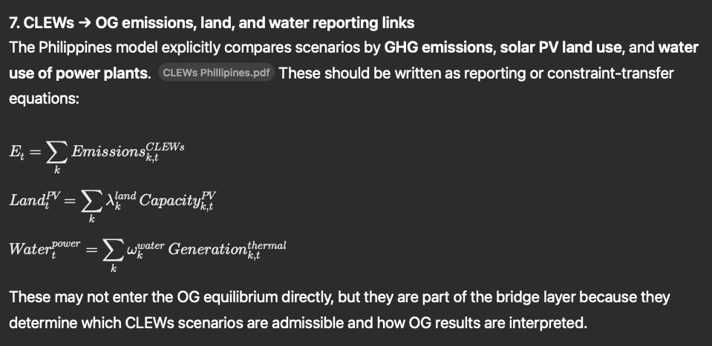
E[t] = Σ_k Emissions[k,t]; Land_PV[t] = Σ_k λ_land[k]·Capacity_PV[k,t]; Water_power[t] = Σ_k ω_water[k]·Generation_thermal[k,t]
Use in bridge layer: Retains climate-resource outputs as policy-screening objects and auxiliary impact channels for the coupled model.
Interpretation: These variables may remain outside the core OG equilibrium in an initial coupling, but they are indispensable for evaluating NDC consistency, land competition, cooling-water stress, and off-model damage channels.

3.9 Iterative coupling rule
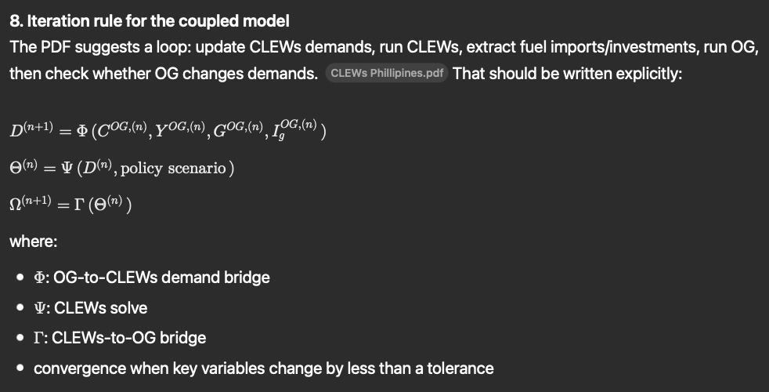
D^(n+1) = Φ(C^OG(n), Y^OG(n), G^OG(n), Ig^OG(n)); Θ^(n) = Ψ(D^(n), policy); Ω^(n+1) = Γ(Θ^(n))
Use in bridge layer: Defines the annual iteration sequence between models until bridge objects converge.
Interpretation: Φ is the OG-to-CLEWs demand bridge, Ψ is the CLEWs solve, and Γ is the CLEWs-to-OG bridge. Convergence can be defined over annual demand, import bill, public investment, delivered costs, emissions, and debt-to-GDP.

4. Minimum mapping table for implementation
Bridge object | Formula or transformation | OG-side object | CLEWs/OSeMOSYS-side object | Implementation note
Demand level | D_CLEWs[f,t] | C_i, Y_m, G, I_g | SpecifiedAnnualDemand | Mandatory first bridge
Demand shape | s[f,l,t] | No native OG equivalent | SpecifiedDemandProfile | Needs auxiliary profile data
Macro harmonization | POP/GDP scaling | Population, GDP path | Demand growth priors | Use for baseline consistency
Fuel imports | M_fuel[t] | Trade/resource wedge | Import technologies or commodity imports | Needed for energy-security stories
Domestic extraction | X_extract[t] | Resource-income or cost wedge | Extraction technologies | Important where fossil depletion matters
Public capex | Ig_OG[m,t] | I_g, K_g, alpha_I | CapitalInvestment by public assets | Classify ownership before transfer
Private capex | Ipriv_OG[m,t] | Private investment demand | CapitalInvestment by private assets | Can be sectoral or aggregate
Delivered cost | uc[f,t] | Household/firms cost wedges | OperatingCost, capex, delivered quantity | Do not replace OG prices directly
Emissions | E[t] | Auxiliary damage/revenue channel | AnnualEmissions | Can feed carbon policy or off-model effects
Land/water | Land_PV[t], Water_power[t] | Constraint or reporting object | PV capacity, thermal generation | Useful for scenario admissibility

5. Recommended insertion into the main annex
• Insert this section immediately after the bridge-layer figure so that the conceptual diagram is followed by an operational formula set.
• Treat equations 3.1 through 3.5 as the minimum viable bridge for a first linked implementation.
• Treat equations 3.6 through 3.8 as the policy-analysis expansion layer needed for climate, affordability, and resource-risk analysis.
• Use equation 3.9 as the formal iteration rule and state the convergence criterion in the model documentation.

6. Source basis used in this addendum
• User-uploaded “CLEWs Philippines - Overview,” especially the model-scope summary, integration pathways, and policy-scenario notes.
• Previously prepared OG-Core ↔ OSeMOSYS coupling map and refined Philippines-generalization annex in this conversation.
• The general OG-Core and OSeMOSYS variable structures already summarized in the main mapping document; this addendum does not redefine those structures, but converts them into implementation-ready bridge formulas.

